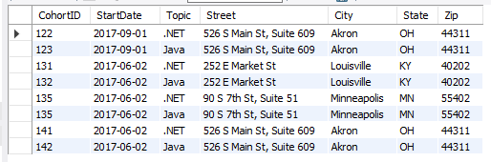

create database paul;

use paul;

create table CohortTable (

CohortID int,

StartDate date,

Topic varchar(200),

Street varchar(200),

City varchar(200),

State varchar(200),

Zip int

);

insert into CohortTable value (122, "2017-09-01", ".NET", "526 S Main St, Suite 609", "Akron", "OH", 44311);

insert into CohortTable value (123, "2017-09-01", "Java", "526 S Main St, Suite 609", "Akron", "OH", 44311);

insert into CohortTable value (131, "2017-06-02", ".NET", "252 E Market St", "Louisville", "KY", 40202);

insert into CohortTable value (132, "2017-06-02", "Java", "252 E Market St", "Louisville", "KY", 40202);

insert into CohortTable value (135, "2017-06-02", ".NET", "90 S 7th St, Suite 51", "Minneapolis", "MN", 55402);

insert into CohortTable value (135, "2017-06-02", "Java", "90 S 7th St, Suite 51", "Minneapolis", "MN", 55402);

insert into CohortTable value (141, "2017-06-02", ".NET", "526 S Main St, Suite 609", "Akron", "OH", 44311);

insert into CohortTable value (142, "2017-06-02", "Java", "526 S Main St, Suite 609", "Akron", "OH", 44311);

select * from CohortTable;

CREATE TABLE ContactsTable (

ContactID INT auto_increment,

FirstName VARCHAR(200),

LastName VARCHAR(200),

PhoneNumber VARCHAR(200),

PhoneType VARCHAR(200),

PRIMARY KEY (`ContactID`));

insert into ContactsTable (FirstName, LastName, PhoneNumber, PhoneType) value ("Bob", "Smith", "555-241-9371", "Home");

insert into ContactsTable (FirstName, LastName, PhoneNumber, PhoneType) value ("Jane", "Doe", "555-241-7235", "Mobile");

insert into ContactsTable (FirstName, LastName, PhoneNumber, PhoneType) value ("Barbara", "Jamison", "555-403-1639", "Mobile");

insert into ContactsTable (FirstName, LastName, PhoneNumber, PhoneType) value ("Joel", "Anthony", "555-403-8820", "Home");

insert into ContactsTable (FirstName, LastName, PhoneNumber, PhoneType) value ("Bob", "Smith", "555-243-9372", "Home");

select * from ContactsTable;

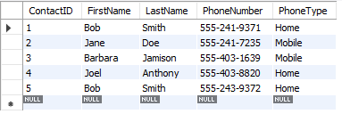

USE paul;

CREATE TABLE EmployeeTable (

empid int NOT NULL,

name VARCHAR(400) NOT NULL,

age int

);

INSERT INTO EmployeeTable VALUE (1, "Bob", 42);

INSERT INTO EmployeeTable VALUE (2, "Jon", 41);

INSERT INTO EmployeeTable VALUE (3, "Grace", 40);

INSERT INTO EmployeeTable VALUE (4, "Hannah", 39);

INSERT INTO EmployeeTable VALUE (5, "Zack", 38);

CREATE UNIQUE INDEX name_ind ON EmployeeTable (name);

SELECT * FROM employeetable;

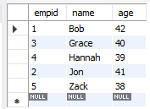

SHOW INDEX FROM EmployeeTable;

